Use Case Proposed Diagram
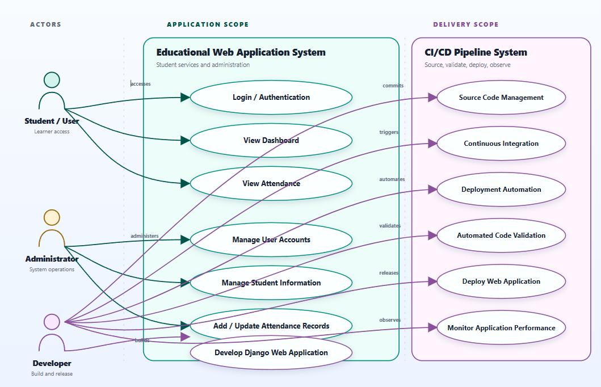
Figure 1 Use Case Diagram prepared in Canva Pro

